TopCoder API NodeJS Framework
Deployment Guide

Revision History
Author | Revision Number | Date
TCSASSEMBLER | 1.0 | 2013/11/9

Deployment Instructions 3
1. Organization of Submission 3
2. Application Setup 3
2.1. Preconditions 3
2.2. Build Script Setup 3
3. Configurations 4
4. Deployment Instructions 5
5. Verification 8
6. Source Verification 13
7. Resource Contact List 15

Deployment Instructions

Organization of Submission
The folder structure (the root directory of the submission is referred as the <base> throughout the document.
Name | Description
tcapi/ | Main application source code of this assembly.  It is in the actionHero app structure.
examples/ | The sample application that is used to get the OAuth 2 access token and test the API in a simple page.  It is an express.js application that hosts the web pages.
docs/ | The folder mainly

Application Setup

Preconditions
- Linux 64bit System (preferably the Ubuntu 10.04), which is used by Heroku stack for Nodejs), with development tool, such as g++, maker.
- Informix Client SDK (used to connect remote Informix Server)
- NodeJS 0.10.21 http://nodejs.org/
- NodeJS-DB-Informix https://github.com/amitkr/nodejs-db-informix
- Git
- Heroku Account and Toolbelt
  - Signup a Heroku account in https://api.heroku.com/signup/devcenter with your email address.
  - Download the Heroku Toolbelt from https://toolbelt.heroku.com, and make sure the Heroku CLI is working in your environment by typing the “heroku help”.

Build Script Setup
Two BASH scripts are used to ease the deployment.
- deploy/development.sh
It helps to launch the application locally.
It simply exports the configured environment variables and then launch the Node.js application.
- deploy/heroku.sh
It helps to deploy the application onto the Heroku cloud.
It has command line switches.
Switch | Description
clean | It cleans the current repository information by simply removing the .git folder.
commit | It initializes the local repository and commits all the current project files, if the current directory is not a GIT repo yet; or commit all the changes to the local repository, if the current directory is already a GIT repo.
create | It creates a Heroku app for the current logged-in Heroku account.  This app will only be used if it is created when the current local GIT repo has not yet setup the remote repo of name “heroku”.  If your local repo has already setup “heroku” remote for an existing app, this app will not be picked as the target app for other Heroku commands. If you want to create an new Heroku app and use it as the target app in this case, you can clean and re-initialize the current local repo first, or you explicitly rebase it to the new Heroku app.
config | It exports all the configured environment variables to the target Heroku app.
push | It pushes the current committed version to the “heroku” remote.
launch | It launches one Heroku dyno to run the target app.
all | It will execute all other steps in the order: “clean”, “commit”, “create”, “config”, “push”, and then “launch”.
deploy | It only executes the steps to deploy the projects to the Heroku cloud: “config”, “push”, and then “launch”.  It assumes the code has been committed to the local repo, and the local repo has setup the “heroku” remote for the target app.

Configurations
There are two BASH scripts used to ease the deployments and launching of the application.
The configurations are defined in these scripts to export the environment variables.
One of them is for local development “tcapi/deploy/development.sh”, where configurations are defined from 3 – line 7, like:
export TC_DB_HOST=50.17.156.219
export TC_DB_PORT=2021
export TC_DB_USER=informix
export TC_DB_PASSWORD=1nf0rm1x
export TC_API_HOST=api.topcoder.com
The other is for deploying the application to Heroku, where the configuration are defined in line 58 – 62, like
heroku config:set TC_DB_HOST=50.17.156.219 \
TC_DB_PORT=2021 \
TC_DB_USER=informix \
TC_DB_PASSWORD=1nf0rm1x \
TC_API_HOST=api.topcoder.com

Deployment Instructions
For the local deployment, you only need to run the “. deploy/development.sh” from within the “tcapi” directory.
This section mainly describes the steps to deploy the application to Heroku. Tutorial for running Node.js application in Heroku can be found here.
The following steps use a BASH script to ease the deployment (see 2.2).
The instructions assume you have installed the Git software, where the command “git” is working.
The instructions assume that you are in Debian/Ubuntu OS (which is used by the Heroku).
The instructions assume that you have Heroku account and have installed the Heroku Toolbelt.

  - Prepare the dependencies
The submission contains all the source code files, without the dependencies (node modules). The IBM library should be downloaded from here, since it is too large. The “thirdparty” directory should be copy to the “tcapi” directory, so that the path to the target directory is “<base>/tcapi/thirdparty/”.
The “nodejs-db-informix” cannot be rebuilt with Node v10, thus you should download the built version from here.
You will then need to go to the “<base>/tcapi” and run the “npm install” to install the other dependencies.

  - Go to the application directory “<base>/tcapi/”.

  - Login your Heroku account by typing the “heroku login”.
This requires you to input your email and password, and then finally it will upload your public SSH key to the server so that you don’t have to provide your credential during the subsequent commands.

  - Run the “. deploy/heroku.sh all” from the directory “<base>/tcapi/”
The script does the following things:
- Initialize the local Git repository, with “git init”
- Commit the files to the local Git repository, with “git add” and “git commit”
- Create an app on the Heroku for testing (this is supposed be used in the first time only), with the “heroku create”
- Set the environment variables to the Heroku app, with the “heroku config:set”.
- Push the application files to the remote repository, with the “git push heroku master”. In the meantime it will be deployed to the Heroku.
If this step yields a “Permission denied (publickey)” error, you can use “heroku keys:add” to add the public key to the remote repo as described here.
- Launch the Heroku Dyno for the app, with the “heroku ps:scale web=1”.
The use of those steps is described in the tutorial.
For the first time to deploy the application, you will only need to run the script with “all” option, from within the application directory (the “tcapi” directory” in our case).
There is the sample screenshot of the output of the script: (the git commit part is ignored since the output of it are too long)
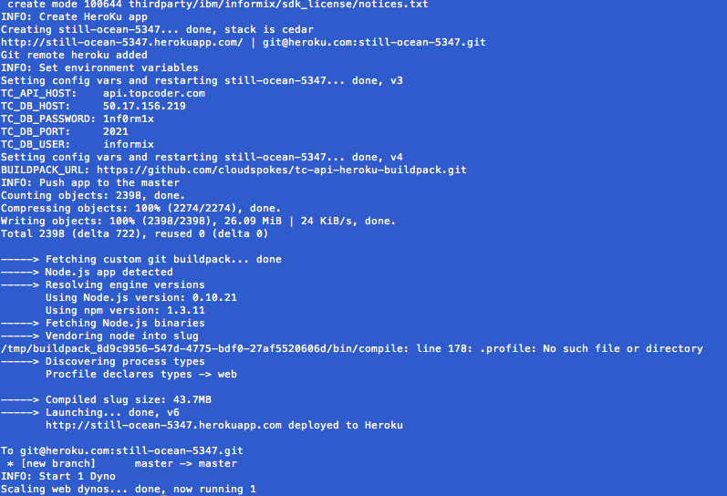
The screenshot shows the output starting from the step where the Heroku app is created.
After running the script, you can use “git remote –v” to see the “heroku” remote repo. The remote repo will be like git@heroku.com:<app-name>.git, you can know the create app name here.

  - Then you can run the “heroku logs” to see the server log.
It will be like this:
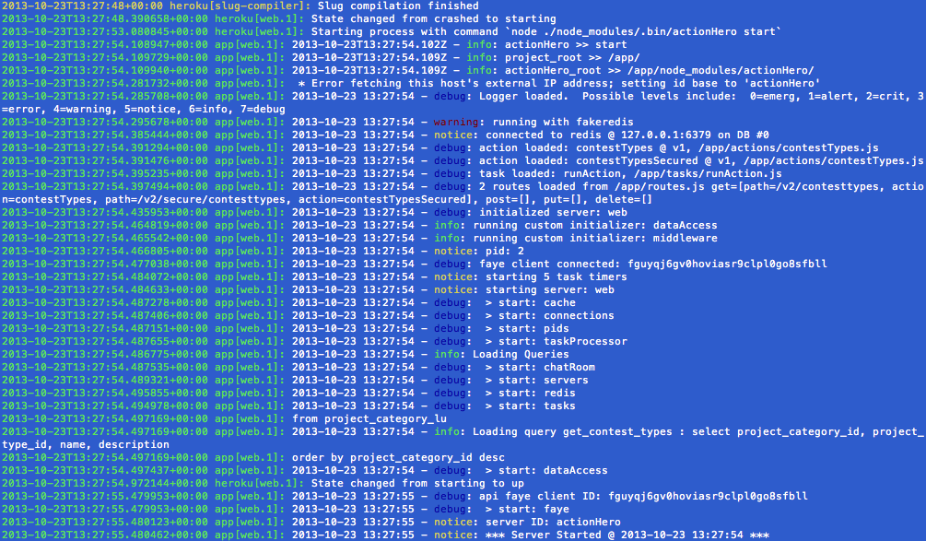

  - You can access to the unprotected “Get Contest Types” API in our browser for quick verification.
The URL will be the http://<your-app>.herokuapp.com/api/v2/contesttypes. It is like:
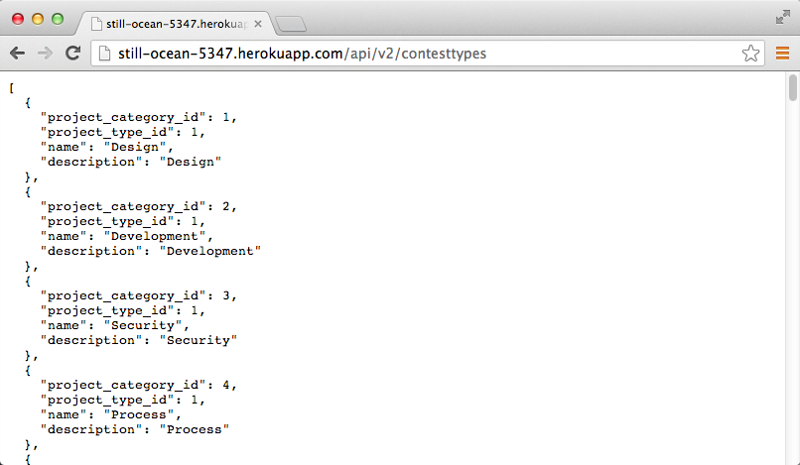

Verification for Member Registration API
The Member Registration API can be verified through mocha and supertest locally. The following describe the verification process step by step, and all operations are done under “<base>/tcapi” directory:
Start the action hero locally with “./deploy/development.sh”.

Open another terminal and execute “./test/test_register_member.sh”. All tests in register_member.js will pass. For details of the verification logic, please refer to register_member.js.

Resource Contact List
Name | Resource Email

